Analysis Specifications

Version Number: | Version 1.0
Analysis Name: | AE Toxicity Analysis Panel
Engine Type /  Engine Version: | SAS 9.2  Excel
Analysis Overview: | The AE Toxicity Analysis Panel provides the user with different analyses to help understand the adverse events present in the study and the frequency of their occurrence by treatment arm. Statistical and frequency reports are generated to provide the user with needed information.
Analysis Description: | The AE Toxicity Analysis Panel contains the analyses as listed below.  Analysis 1: Toxicity Grade Summary  This analysis shows how many and what proportion of each arm's subjects experienced any adverse event, for all toxicity grades and for toxicity grades 3, 4, and 5.  Analysis 2&3: Preferred Term Analysis by Toxicity Grade  This analysis lists all adverse events that appeared in the study and shows how many and what proportion of subjects experienced each adverse event in each arm, for all toxicity grades and for toxicity grades 3, 4, and 5.  Analysis 4&5: Two-Term MedDRA Analysis  This analysis lists all adverse events that appeared in the study that correspond to two user-selected MedDRA levels and shows how many and what proportion of subjects experienced each adverse event in the treatment arm and the control arm for user-selected toxicity grades.  This analysis also gives risk differences, relative risks, odds ratios, confidence limits for 95% confidence intervals for these statistics, and p-values for these adverse events.
Precondition(s): | The Oncology Adverse Events Analysis has the following preconditions:  - A Demographics (DM) dataset has to exist according to CDISC format specifications  - The Demographics variables actual arm (ACTARM) or planned treatment arm (ARM) and subject id (USUBJID) must be present.  - Planned arm code (ARMCD), subject reference start date/time (RFSTDTC), and subject reference end date/time (RFENDTC) will be used if present but are not necessary  - An Adverse Event (AE) dataset has to exist according to CDISC format specifications  - The Adverse Event variables subject id (USUBJID), body system or organ class (AEBODSYS), and dictionary derived term (AEDECOD) must be present  - Toxicity grade (AETOXGR) and adverse event start date/time (AESTDTC) will be used if present but are not necessary  - An Exposure (EX) dataset has to exist according to CDISC format specifications  - The Exposure variable subject id (USUBJID) must be present in the EX dataset  - Exposure start date/time (EXSTDTC) and end date/time (EXENDTC) will be used if present but are not necessary  - A MedDRA hierarchy dataset exists for the version the user selects  - The user selects the following analysis panel options in the Script Launcher interface (discussed more in the next section for Panel Options):  - The number of days following a subject’s last exposure or reference end date after which adverse events are not considered for analysis  - Whether to group toxicity grades 3, 4, and 5 or group 3 and 4 and separately 5  - For the two-term MedDRA analysis, the treatment and control arms  - For the two-term MedDRA analysis, the MedDRA version  - For the two-term MedDRA analysis, the two levels of the MedDRA hierarchy to use in comparison  - For the two-term MedDRA analysis, the toxicity grades to compare  - For the two-term MedDRA analysis, the continuity correction  - For the two-term MedDRA analysis, the variable to sort the last tab by
Panel Options: | The following is a list of topics and values that the user is required to enter from the panel options page of the Script Launcher. The value chosen will be used in the analysis:
  Topic | Possible Values | Default
  MedDRA Version | N/A, 13.1, 13.0, 12.1, 12.0, 11.0, 10.1, 10.0, 9.1, 9.0, 8.1, 8.0, 7.1, 6.1, 6.0, 5.1, 5.0, 4.1, 4.0 | 13.1
  End Day for Study Analysis | Numbers 0 - 60 | 30
  Continuity Correction | None, 0.5, 1, 1/Other Arm Count | 1
  Toxicity Grade Grouping | 1) All Grades, Grades 3 and 4, Grade 5  2) All Grades, Grades 3 and above | All Grades, Grades 3 and above
  Control Arm | Pulled from DM data or grouping | --
  Treatment Arm | Pulled from DM data or grouping | --
  Two-term MedDRA Analysis | SOC/PT  SOC/HLT  SOC/HGLT  HGLT/HLT  HGLT/PT  HLT/PT | SOC/PT
  Comparison Metric | All Grades  Grades 3 and 4  Grades 3, 4, and 5  Grade 5 | All Grades
  Sort by | Risk Difference  Relative Risk  Odds Ratio  P-Value | Risk Difference
Input from: | There are three different types of inputs for this analysis panel:  - The CDISC datasets required to perform the Oncology Adverse Events analysis are chosen by the user and provided by Script Launcher  - The MedDRA hierarchy dataset is stored on the Script Launcher server in a fixed location  - The panel options discussed above
Input(s): | The Adverse Event Analysis uses the following data and variables:  - DM –  - ACTARM  - ARM  - ARMCD (optional)  - USUBJID  - RFSTDTC (optional)  - RFENDTC (optional)  - AE –  - AEDECOD  - AEBODSYS  - AETOXGR (optional)  - USUBJID  - AESTDTC (optional)  - EX –  - USUBJID  - EXSTDTC (optional)  - EXENDTC (optional)  - MDHIER_X_Y (where X.Y is the version number)  - AEDECOD  - AEBODSYS  - SOC_NAME  - HLGT_NAME  - HLT_NAME  - PT_NAME
Process Flow: | The process flow diagram below provides the user a graphical representation of the Adverse Event Analysis steps.  Data Pre-processing  DM  EX  DM_EX  USUBJID  ACTARM  EXSTDTC/  RFSTDTC  EXENDTC/  RFENDTC  AE  USUBJID  AEBODSYS  etc.  AESTDTC  AE_DM_EX  where AE.USUBJID = DM_EX.USUBJID  and AESTDTC between STDTC and ENDTC + X days  Analysis 1: Toxicity Grade Summary  AE_DM_EX  DM_EX  USUBJID  ACTARM  AETOXGR  Count of USUBJID  with an adverse event  per ACTARM  USUBJID  ACTARM  Count of USUBJID  per ACTARM  Percentage of USUBJID  per ACTARM  with AEBODSYS/AEDECOD  Output to Excel Spreadsheet  Count of USUBJID  with max. tox. grade 3,4,5  per ACTARM  Analysis 2&3: Preferred Term Analysis by Toxicity Grade  AE_DM_EX  DM_EX  USUBJID  ACTARM  AEBODSYS  AEDECOD  Count of USUBJID  per AEBODSYS/AEDECOD  per AETOXGR and ACTARM  USUBJID  ACTARM  Count of USUBJID  per ACTARM  Percentage of USUBJID  per ACTARM  with AEBODSYS/AEDECOD  at all AETOXGR  and at AETOXGR 3/4/5  Output to Excel Spreadsheet  AETOXGR  Analysis 4&5: Preferred Term Analysis by Toxicity Grade  AE_DM_EX  DM_EX  USUBJID  ACTARM  AEBODSYS  AEDECOD  Count of USUBJID  per MedDRA term pair  per AETOXGR and ACTARM  USUBJID  ACTARM  Count of USUBJID  per ACTARM  Percentage of USUBJID  per ACTARM  with MedDRA term pair  Risk difference, relative risk, odds ratio, p-value  Output to Excel Spreadsheet  AETOXGR  SOC  HLGT  HLT  PT  MDHIER
Requirements: | The Oncology Adverse Event analysis shall perform and execute the following steps within the prescribed order:  Data Pre-processing:  - Identify the Adverse Events, Demographic, and Exposure Datasets.  - Determine whether the Adverse Events, Demographics, and Exposure Datasets are in the prescribed CDISC SDTM format and whether the variables within the dataset comply with CDISC SDTM standards.  - Adverse Events AE  - Demographics Dataset DM  - Exposure Dataset EX  - Determine whether the needed Demographic variables are present within the Demographics Dataset (DM).  - If ARMCD exists then if ARMCD is equal “SCRNFAIL” or “NOTASSGN” then delete  - If ACTARM exists, then use it as the subject’s arm, otherwise use ARM  - ACTARM  - ARM  - ARMCD (optional)  - USUBJID  - RFSTDTC (optional)  - RFENDTC (optional)  - Determine whether the needed Adverse Events variables are present within the Adverse Events Dataset (AE).  - AEDECOD  - AEBODSYS  - AETOXGR (optional)  - USUBJID  - AESTDTC (optional)  - Determine whether the needed Exposure variables are present within the Exposure Dataset (EX)  - USUBJID  - EXSTDTC (optional)  - EXENDTC (optional)  - If all required variables are present then proceed.  - Find all distinct subjects (USUBJID) in EX. This is the safety population  - Find the earliest exposure start date (EXSTDTC) and the latest exposure end date (EXENDTC) for each subject  - Join DM and the distinct USUBJID of EX found above and keep those observations where  - USUBJID is in both  - The subject’s planned arm code (ARMCD in DM) is not ‘NOTASSGN’ or ‘SCRNFAIL’  - If EXSTDTC and EXENDTC exist and the subject has exposure start and end dates from EX, use those as the subject’s treatment start and end dates. Otherwise, if RFSTDTC and RFENDTC exist, use the subject’s reference start and end dates (RFSTDTC and RFENDTC) . If date variables exist but a given subject has no dates, exclude them from the analysis.  - The observations found here will be henceforth referred to as DM_EX.  - Join AE and DM_EX by USUBJID and keep those observations where  - USUBJID is in both  - If EXSTDTC and EXENDTC or RFSTDTC and RFENDTC exist then validate the adverse events by comparing their start dates to the subject’s treatment dates  - The start date of the adverse event (AESTDTC in AE) must be equal to or after the subject’s treatment start date and before or equal to the subject’s treatment end date + the number of days specified by the user afterwards  - These date/times are stored in text as ISO 8601 format.  - If the length of the string is 10 or greater, it will contain year, month, and day.  - Otherwise, if the length of the string is 7 or greater, it will contain only year and month.  - The observations found here will henceforth be referred to as AE_DM_EX  Analysis 1: Toxicity Grade Summary  - This analysis lists how many and what proportion of subjects experienced any adverse event per arm at any toxicity grade, and at either toxicity grades 3, 4, and 5, or 3 and 4 and separately 5, depending on the user’s selection.  - Using dataset AE_DM_EX found in 1.8, find the count of subjects experiencing each adverse event (AEBODSYS/AEDECOD combination) at each toxicity grade by arm (ACTARM or ARM) using the maximum toxicity grade per subject  - Reduce AE_DM_EX to one row per subject with the maximum toxicity grade for that subject  - The formula for the count of subjects experiencing any adverse event at a given toxicity grade in a given arm is as follows  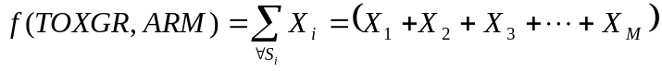  where  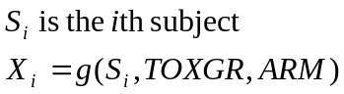  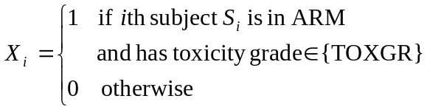  - Using dataset DM_EX found in 1.7, find the count of subjects (USUBJID) per arm (ARM)  - The formula for the count of subjects in a given arm is as follows  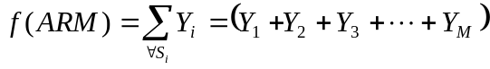  where  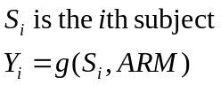  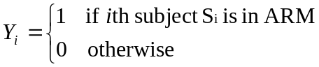  - Using the counts of subjects experiencing any adverse event per arm at each toxicity grade found in 3.1 and the counts of subjects per arm found in 3.2, find the percentage of subjects experiencing an adverse event per arm for all toxicity grades and for grades 3/4/5 or 3/4 and 5  - The formula for this percentage for arm ARM is as follows  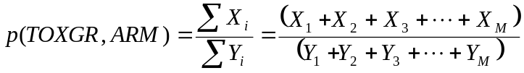  where X and Y are defined as above  This analysis shows information for all toxicity grades combined and for either toxicity grades 3, 4, and 5 or 3 and 4 together and separately 5. So for this formula, TOXGR should be interpreted as accepting a list of values as an argument, with missing values falling into the all toxicity grades category.  - Export the results to an Excel spreadsheet listing the counts and percentages by arm  Analysis 2&3: Preferred Term Analysis by Toxicity Grade  - This analysis lists how many and what proportion of subjects experienced each adverse event per arm at any toxicity grade, and at either toxicity grades 3, 4, and 5, or 3 and 4 and separately 5, depending on the user’s selection.  - Using dataset AE_DM_EX found in 1.8, find the count of subjects experiencing each adverse event (AEBODSYS/AEDECOD combination) at each toxicity grade by arm (ACTARM or ARM) using the maximum toxicity grade per subject  - Reduce AE_DM_EX to one row per subject and AEBODSYS/AEDECOD pair with the maximum toxicity grade for that subject and AEBODSYS/AEDECOD pair  - The formula for the count of subjects experiencing a given adverse event AE at a given toxicity grade in a given arm is as follows  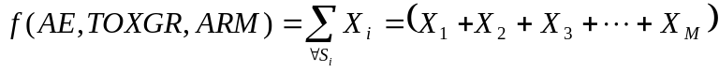  where  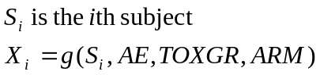  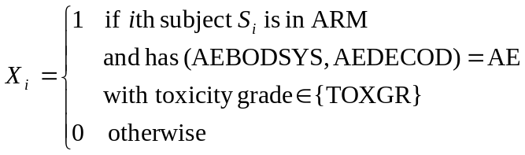  - Using dataset DM_EX found in 1.7, find the count of subjects (USUBJID) per arm (ARM)  - The formula for the count of subjects in a given arm is as follows  where  - Using the counts of subjects experiencing each adverse event per arm found in 3.1 and the counts of subjects per arm found in 3.2, find the percentage of subjects experiencing each adverse event per arm at all toxicity grades and at toxicity grades 3, 4, and 5 or grades 3 and 4 and separately 5, depending on the user’s panel option selection  - The formula for this percentage for a given adverse event AE, toxicity grade TOXGR, and arm ARM is as follows  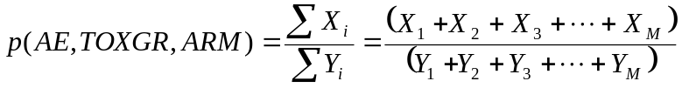  where X and Y are defined as above  TOXGR is a list of toxicity grades; to compute the percentage of subjects with AE at all toxicity grades for example, TOXGR will be {1,2,3,4,5,missing}  - Export the results to an Excel spreadsheet listing each adverse event and its counts and percentages by arm. This output is created in two versions:  - The first (V1) shows the body system or organ class on each row and is formatted for sorting and filtering using the autofilter function in Excel;  - The second (V2) has header rows at the top of each body system or organ class (AEBODSYS) group instead of in each row and is suited for printing  Analysis 4&5: Two-Term MedDRA Analysis  - This analysis compares a treatment arm and a control arm of the user’s selection using the MedDRA terms corresponding to those arms’ adverse events. The two levels of the MedDRA hierarchy the arms are compared at are chosen by the user. It shows counts, percentages, and confidence intervals for the percentages of each arm with each adverse event. It also shows the risk difference, relative risk, odds ratio, confidence intervals for these, and a p-value testing difference in proportion.  - Merge dataset AE_DM_EX found in 1.8 with the MedDRA hierarchy, using the MedDRA version the user specifies, matching the AEBODSYS to the system organ class (SOC or SOC_NAME) and the AEDECOD to the preferred term (PT or PT_NAME)  - If less than 80 percent of the adverse events correspond to MedDRA terms, default to using the AEBODSYS and AEDECOD instead of the user’s chosen MedDRA hierarchy levels  - Reduce the dataset found above to one row per subject and the two levels of the MedDRA hierarchy chosen by the user, for example, SOC and HLGT, using the maximum toxicity grade per subject for the adverse events. For example, if a subject has three adverse events that fall under a given SOC/HLGT pair with toxicity grades 2, 3, 3, then this subject will have one row for this SOC/HLGT pair and its toxicity grade will be 3.  - Using dataset found in 4.2, find the count of subjects experiencing each adverse event at the toxicity grades chosen by the user (for example, all toxicity grades) per (ACTARM or ARM)  - The formula for the count of subjects experiencing a given adverse event AE at a given toxicity grade in a given arm is as follows  where  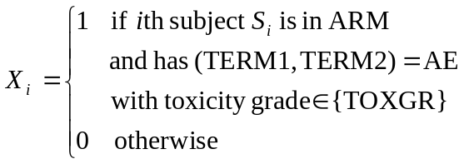  - Using dataset DM_EX found in 1.7, find the count of subjects (USUBJID) per arm (ARM)  - The formula for the count of subjects in a given arm is as follows  where  - Using the counts of subjects experiencing each adverse event per arm found in 4.3 and the counts of subjects per arm found in 4.4, create the following 2x2 contingency table to calculate the statistics that follow between the user’s chosen treatment arm and control arm  a and c are the counts of subjects who experienced this adverse event in the treatment arm and control. b and d are the counts of subjects in each arm that did not experience the adverse event.  - Find the percentage of each arm that experience each adverse event and the Clopper-Pearson exact 95% confidence interval for the user’s chosen set of toxicity grades to analyze (e.g. grades 3, 4, and 5)  - The formula for this percentage for a given adverse event AE, toxicity grade (TOXGR), and arm (ACTARM or ARM) is as follows  where X and Y are defined as above  or in terms of the contingency table  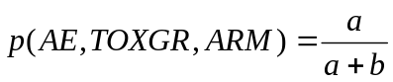  for the treatment arm  TOXGR is a list of toxicity grades; to compute the percentage of subjects with AE at all toxicity grades for example, TOXGR will be {1,2,3,4,5,missing}  - Clopper-Pearson exact confidence intervals are found using the BINOMIAL option on the EXACT statement in SAS’s FREQ procedure  - Find the risk difference between the two arms and asymptotic 95% confidence interval  - Risk difference (RD) is computed using the following  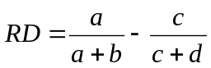  - The asymptotic 95% confidence interval for risk difference is found using the RISKDIFF option on the TABLE statement in SAS’s FREQ procedure  - Find the relative risk between the two arms and asymptotic 95% confidence interval  - Relative risk (RR) is computed using the following  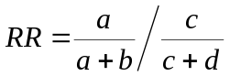  - The user will also be able to choose to add continuity corrections, which handle cases with a zero cell count that would lead to an undefined relative risk statistic.  - The continuity correction is added to each cell in the 2x2 contingency table before calculating relative risk only for those adverse events that have a zero cell count  - The options are 1 (Laplace’s method), ½ (Yates’ method), and the reciprocal of the opposite arm subject count (Sweeting et. al.)  - The asymptotic 95% confidence interval for relative risk is found using the RELRISK option on the TABLE statement in SAS’s FREQ procedure  - Find the odds ratio between the two arms and exact or asymptotic 95% confidence interval  - Odds ratio (OR) is computed using the following  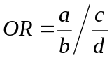  - The user will also be able to choose to add continuity corrections, which handle cases with a zero cell count that would lead to an undefined odds ratio statistic.  - The continuity correction is added to each cell in the 2x2 contingency table before calculating odds ratio only for those adverse events that have a zero cell count  - The options are No Continuity correction, 1 (Laplace’s method), 0.5 (Yates’ method), and the reciprocal of the opposite arm subject count (Sweeting et. al.)  - The exact 95% confidence interval for odds ratio is found using the OR option in the EXACT statement; the asymptotic 95% confidence interval for odds ratio is found using the RELRISK option on the TABLE statement; both are used in SAS’s FREQ procedure  - Exact confidence intervals should be used wherever available; they will not be available when using non-integer continuity corrections  - Find the p-value from Fisher’s exact test of difference in proportion using the FISHER option on the EXACT statement in SAS’s FREQ procedure  - Export the results to an Excel spreadsheet listing each adverse event, its counts and percentages by arm, and the statistics comparing the two arms. This output is created in two versions:  - The first (V1) shows the higher MedDRA hierarchy level on each row and is formatted for sorting and filtering using the autofilter function in Excel;  - The second (V2) has header rows at the top of each higher MedDRA hierarchy level (e.g. SOC) group instead of in each row and is suited for printing. This version is sorted by a variable the user selects. Sorting is done by group; e.g. the group of adverse events belonging to the higher MedDRA level term with the highest value for the sort variable are placed first, and so on. If the user sorts by p-value, the group with the lowest p-value is placed first.
   | Treatment | Control
  Adverse event | a | c
  No adverse event | b | d
Screenshots: | Analysis 1: Toxicity Grade Summary  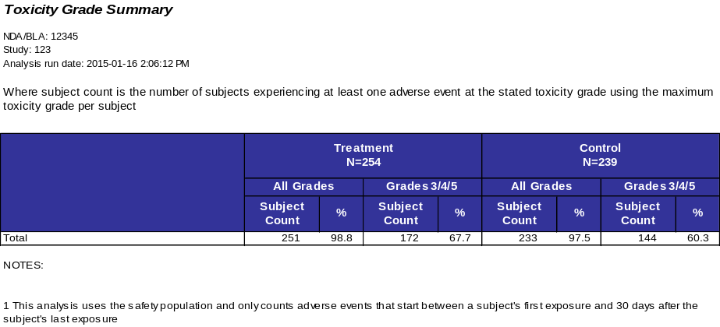  Analysis 2: Preferred Term Analysis by Toxicity Grade (V1)  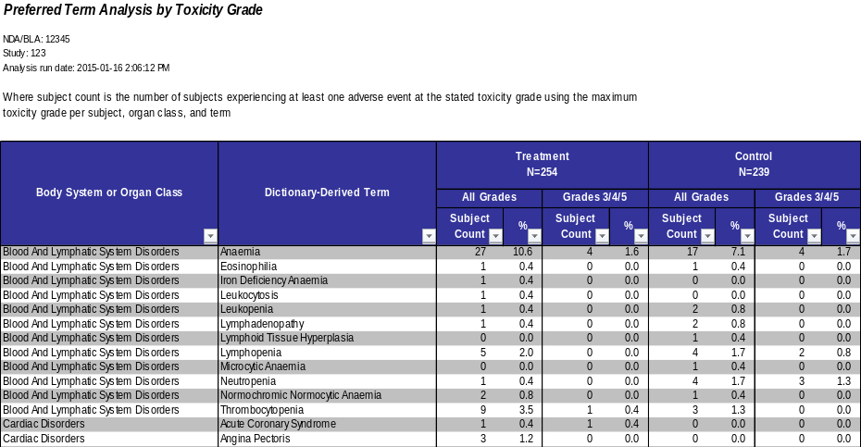  Analysis 3: Preferred Term Analysis by Toxicity Grade (V2)  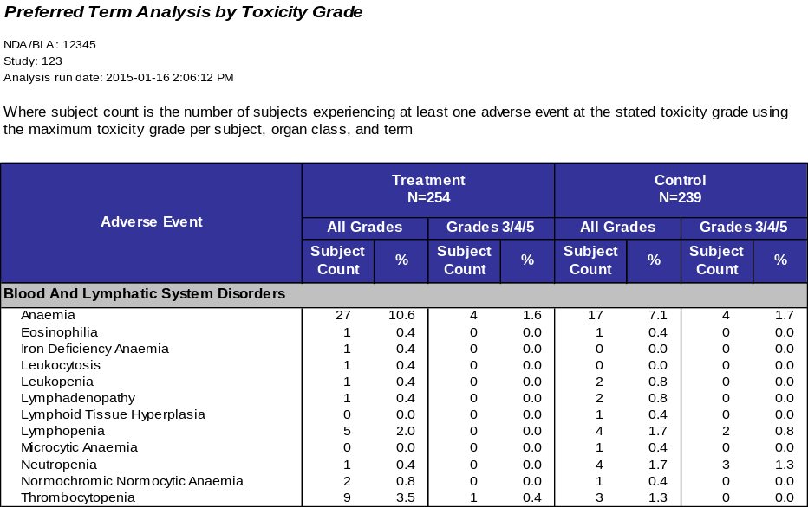  Analysis 4: Two-Term MedDRA Analysis (V1)  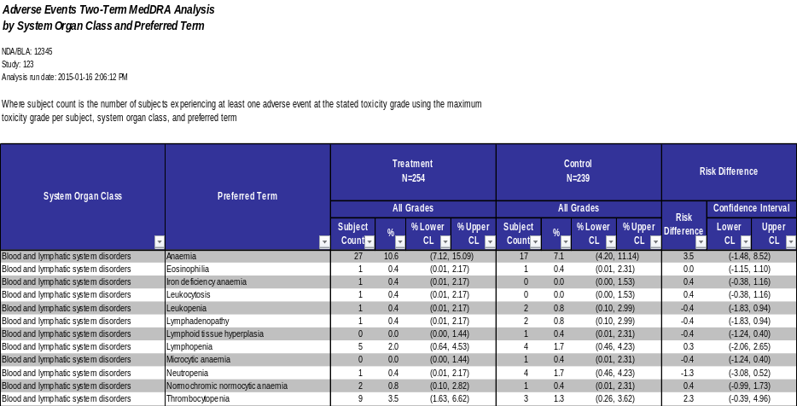  Analysis 5: Two-Term MedDRA Analysis  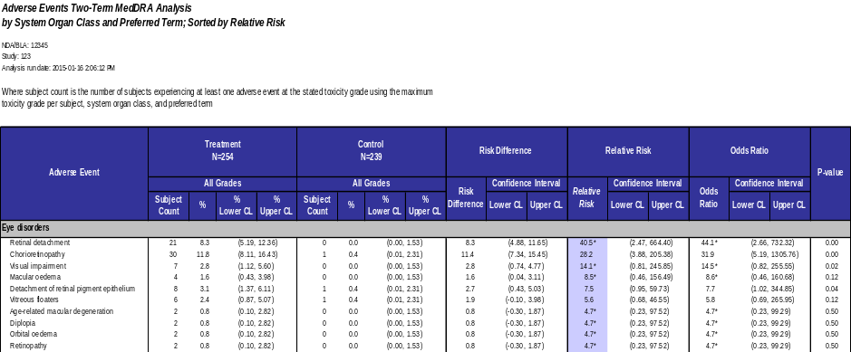
Output to: | An Excel workbook with 5 worksheets for the analysis: 1 worksheet for the toxicity grade summary, and two each for the preferred term analysis by toxicity grade and for the two-term MedDRA comparison
Data Checks: | - Keep counts and percentages of subjects excluded in total and per arm for the following reasons  - Not assigned or screen failure – ARMCD in (‘SCRNFAIL’,’NOTASSGN’)  - Not in the safety population – not in EX  - No treatment start and end dates  - Keep counts and percentages of adverse events excluded per arm for the following reasons  - The adverse event start date was missing or could not be decoded into a date containing at least month and year  - The adverse event start date was outside the subject’s treatment period + user-defined number of days following the end of treatment  - The body system or organ class (AEBODSYS) or dictionary-derived term (AEDECOD) was missing  - Keep counts and percentages of subject’s adverse events that were included in the analysis were missing toxicity grades per arm  - Keep a list and counts and percentages of the adverse events that that did not match to any MedDRA terms
Assumptions: | The Oncology Adverse Event analysis panel assumes:  - The user has access to the following CDISC SDTM datasets: Demographic (DM), Adverse Event (AE), and Exposure (EX).  - The user knows the MedDRA version used in the study being analyzed  - The analysis can only be used to examine treatment sequences in cross-over studies and not individual treatments  - The user has a basic understanding of the statistical significance behind the risk difference, relative risk, odds ratio, and p-value for difference in proportion calculations.
Notes and Issues: | Limitations:  - If ACTARM is not available, the panel defaults to using planned treatment arm (ARM) as there is no way to automatically determine the actual treatment arm otherwise  - The panel currently relies on matching the standardized adverse event descriptions in the adverse events domain to MedDRA terms and only handles information down to the preferred term level; future versions of SDTM will include the MedDRA hierarchy information in the AE dataset itself and may include the lower-level term  - The panel currently relies on subject’s reference start and end date in the demographics domain, or on their first and last exposure events in the exposure domain, rather than on dates explicitly stating when participation or treatment started or ended
Approval /  Validation Status: | Status Pending and Validation Required.
Created By: | David Kretch
Date Created: | 04/25/2011 | Last Updated By: | David Kretch

Appendix

SAS Source Code
/****************************************************************************/
/* */
/* PROGRAM NAME: Oncology Adverse Events Panel */
/* */
/* DESCRIPTION: Find subject counts per arm for each adverse event */
/* broken down by toxicity grade */
/* Compare the AEs between two arms and find */
/* risk difference, relative risk, odds ratio, */
/* 95% confidence intervals, and p-value */
/* */
/* EVALUATION TYPE: Safety */
/* */
/* AUTHOR: David Kretch (david.kretch@us.ibm.com) */
/* */
/* DATE: February 7, 2011 */
/* */
/* EXTERNAL FILES USED: ae_setup.sas -- Merges AE, DM, and EX */
/* ae_oncology_aggregate.sas -- Does the analysis */
/* ae_oncology_output.sas -- Creates the output */
/* xml_output.sas -- XML formatting macros */
/* data_checks.sas -- Generic variable checks */
/* sl_gs_output.sas -- Script Launcher settings output*/
/* err_output.sas -- Error output when missing vars */
/* mdhier_x_y.sas7bdat -- MedDRA hierarchy ver. X.Y */
/* */
/* PARAMETERS REQUIRED: meddrapath -- location of MedDRA hierachy datasets */
/* saspath -- location of the external SAS programs */
/* utilpath -- location of the external SAS programs */
/* */
/* study_lag -- window in days after last exposure */
/* where AEs should be kept in analysis */
/* */
/* toxgr_min -- minimum valid toxicity grade */
/* toxgr_max -- maximum valid toxicity grade */
/* toxgr_grp5_sw -- group toxgrade 5 with 3&4 */
/* */
/* ver -- MedDRA version */
/* exp -- comparison treatment arm number */
/* ctl -- comparison control arm number */
/* cmptrm -- MedDRA levels to compare */
/* cmpgr -- toxicity grades to compare */
/* cmpsort -- variable to sort formatted output by */
/* cc -- continuity correction value */
/* */
/* LOCAL ONLY: studypath -- location of the drug study datasets */
/* outpath -- location of the output */
/* */
/* VARIABLES REQUIRED: AE -- AEBODSYS */
/* AEDECOD */
/* USUBJID */
/* DM -- ACTARM or ARM */
/* USUBJID */
/* EX -- USUBJID */
/* */
/* VARIABLES USED: AE -- AESTDTC */
/* WHEN AVAILABLE AETOXGR */
/* DM -- RFSTDTC */
/* RFENDTC */
/* ARMCD */
/* EX -- EXSTDTC */
/* EXENDTC */
/* */
/* MADE WITH: SAS 9.2 */
/* */
/* NOTES: */
/* */
/****************************************************************************/

/* REVISIONS */
/*
2011-03-26 DK Script Launcher parameter mapping
handling for MedDRA version 'N/A'
*/

/* the minoperator option allows the use of the in operator by the macro language */
options minoperator;
options missing='';

/* determine the run location by looking for the SL-set run_location macro variable */
%sysfunc(ifc(not %symexist(run_location),%nrstr(%let run_location = local;),));
%put RUN LOCATION: &run_location.;

%macro params;

/* program parameters if the program is run locally */
%if %upcase(&run_location.) = LOCAL %then %do;

data macrovar; set sashelp.vmacro(keep=scope name where=(scope='GLOBAL' & name ne 'RUN_LOCATION')); run;
data _null_; set macrovar; call execute('%symdel '||trim(left(name))||';'); run;
proc datasets kill; quit;

%global panel_title panel_desc;
%let panel_title = Oncology Adverse Events;
%let panel_desc = ;

%global saspath utilpath;
%let saspath = C:\Documents and Settings\MATTOK\Desktop\SL_SAS_Progs\AdverseEventsOncology;
%let utilpath = C:\Documents and Settings\MATTOK\Desktop\SL_SAS_Progs\ZZ_Utilities;

%global oncaeout errout;
%let outpath = C:\Documents and Settings\MATTOK\Desktop\Output;
%let oncaeout = &outpath.\Oncology Adverse Events Analysis.xls;
%let errout = &outpath.\Oncology Adverse Events Error Summary.xls;

%let studypath = C:\Documents and Settings\MATTOK\Desktop\Data\NDA12345;

libname inlib "&studypath.";

/* retrieve the required datasets */
data ae; set inlib.ae; run;
data dm; set inlib.dm; run;
data ex; set inlib.ex; run;

/* NDA/BLA and study number */
%global ndabla studyid;
%let ndabla = 12345;
%let studyid = 123;

/* MedDRA hierachy */
%let meddrapath = C:\Documents and Settings\MATTOK\Desktop\Data\MedDRA;

libname meddra "&meddrapath.";

/* MedDRA version */
%global ver meddra meddra_pct;
%let ver = 12.0;
%if %upcase(%substr(&ver.,1,1)) = N %then %do;
%let meddra = N;
%let meddra_pct = 0;
%end;
%else %let meddra = Y;

/* study lag in days; determines window in days following the end of a study */
/* in which AEs should be included in the analysis */
%global study_lag;
%let study_lag = 30;

/*****************************/
/* TOXICITY GRADE PARAMETERS */
/*****************************/

/* toxicity grade 5 grouping switch to group 5 with 3 and 4 in the oncology panel */
%global toxgr_grp5_sw;
%let toxgr_grp5_sw = 1;

/*************************/
/* COMPARISON PARAMETERS */
/*************************/

/* experiment and control */
/* defined by arm number from all_arm */
%global exp ctl;
%let exp = 1;
%let ctl = 2;

/* comparison terms */
%global cmptrm;
%let cmptrm = soc_name,pt_name;

/* grades to use in comparison in the two-term analysis */
/* valid values: all, 5, 34, 345 */
%global cmpgr;
%let cmpgr = all;

/* sort variable */
%global cmpsort;
%let cmpsort = rr;

/* continuity correction method */
/* arm adds the reciprocal of the opposite arm */
/* otherwise any number is added as a constant */
%global cc;
%let cc = 1;

/* dummy grouping, subsetting, and dataset information datasets */
data sl_datasets;
datatype = ''; name = ''; partition_variable = ''; default = '';
delete;
run;
data sl_group;
group_name = ''; domain = ''; partition = ''; var_name = ''; var_value = ''; dsvg_grp_name = '';
delete;
run;
data sl_subset;
name = ''; domain = ''; partition = ''; var_name = ''; var_value = ''; inner_operator = ''; outer_operator = '';
delete;
run;

%end;

/* program parameters if the program is run through Script Launcher */
%else %do;

/* MedDRA hierachy */
libname meddra "&meddrapath.";

/* map the user-defined Script Launcher panel option values onto panel macro variables */
data _null_;

/* MedDRA version */
meddraver = "&meddraver.";
meddra = ifc(upcase(substr("&meddraver.",1,1)) = 'N','N','Y');
call symputx('ver',meddraver,'g');
call symputx('meddra',meddra,'g');
if meddra = 'N' then call symputx('meddra_pct','0','g');

/* study lag */
length study_lag $15;
study_lag = trim(left("&study_lag."));
call symputx('study_lag',study_lag,'g');

/* toxicity grade grouping */
select ("&tox_grade.");
when ('All Grades, Grades 3 and 4, Grade 5') toxgr_grp5_sw = 0;
when ('All Grades, Grades 3 and above') toxgr_grp5_sw = 1;
otherwise toxgr_grp5_sw = 0;
end;
call symputx('toxgr_grp5_sw',toxgr_grp5_sw,'g');

/* comparison terms */
meddracomp = lowcase(left(trim("&meddracomp.")));
cmptrm_1 = trim(scan(meddracomp,1,'/'))||'_name';
cmptrm_2 = trim(scan(meddracomp,2,'/'))||'_name';
cmptrm = trim(cmptrm_1)||','||trim(cmptrm_2);
call symputx('cmptrm',cmptrm,'g');

/* toxicity grades to use in the two-term comparison */
length cmpgr $15;
select ("&compmet.");
when ('All Grades') cmpgr = 'all';
when ('Grades 3 and 4') cmpgr = '34';
when ('Grades 3, 4, and 5') cmpgr = '345';
when ('Grade 5') cmpgr = '5';
otherwise cmpgr = 'all';
end;
call symputx('cmpgr',cmpgr,'g');

/* sort-by variable for the two-term analysis formatted tab */
length cmpsort $15;
select ("&sortby");
when ('Risk Difference') cmpsort = 'rd';
when ('Relative Risk') cmpsort = 'rr';
when ('Odds Ratio') cmpsort = 'ort';
when ('P-Value') cmpsort = 'p_value';
otherwise cmpsort = 'rd';
end;
call symputx('cmpsort',cmpsort,'g');

/* continuity correction */
length cc $15;
select (upcase(compress("&cont_corr.")));
when ('1') cc = '1';
when ('0.5','1/2') cc = '0.5';
when ('1/OTHERARMCOUNT') cc = 'arm';
when ('NONE','0') cc = '0';
otherwise cc = '0';
end;
call symputx('cc',cc,'g');
run;

%end;

%mend params;

%params;

/* data validation switch; determines whether to perform data validation on AEs */
%let vld_sw = 1;

/* minimum and maximum toxicity grades for oncology panel */
%global toxgr_min toxgr_max;
%let toxgr_min = 1;
%let toxgr_max = 5;

/* include confidence limits for AE rates (risks) 1=on, 0=off */
%let ae_rate_ci_sw = 1;

%include "&utilpath.\ae_setup.sas";
%include "&saspath.\ae_oncology_aggregate.sas";
%include "&saspath.\ae_oncology_output.sas";
%include "&utilpath.\data_checks.sas";
%include "&utilpath.\sl_gs_output.sas";
%include "&utilpath.\xml_output.sas";

/* set the continuity correction switch */
/* set the cc whole number switch */
data _null_;
if anyalpha("&cc.") then cc = "&cc.";
else cc = &cc.;

if anyalpha(cc) and cc = 'arm' then cc_sw = 2;
else if not missing(cc) and cc ne 0 then cc_sw = 1;
else cc_sw = 0;

if cc_sw = 2 then cc_whole = 0;
else if (cc - floor(cc) ne 0) then cc_whole = 0;
else cc_whole = 1;

call symputx('cc_sw',cc_sw,'g');
call symputx('cc_whole',cc_whole,'g');
run;

%macro onc;

%if %upcase(%substr(&ver.,1,1)) = N %then %do;
%setup;
%global meddra; %let meddra = N;
%end;
%else %setup(mdhier=Y);

/* determine the treatment and control arms from user-defined Script Launcher panel options */
/* if the arms cannot be determined, set it to two arms in the study */
%if %upcase(&run_location.) ne LOCAL %then %do;
data _null_;
set all_arm end=eof;

retain exp;
if upcase(compbl(trim(arm))) =: upcase(compbl(trim("&treat_arm."))) then exp = arm_num;
retain ctl;
if upcase(compbl(trim(arm))) =: upcase(compbl(trim("&cont_arm."))) then ctl = arm_num;

if eof then do;
if exp = . then exp = 1;
if ctl = . then ctl = min(2,&arm_count.);

call symputx('exp',put(exp,8. -l),'g');
call symputx('ctl',put(ctl,8. -l),'g');
end;
run;
%end;

%if &setup_success. %then %do;

/* you cannot group 5 with 3 and 4 if 4 is the upper bound */
/* ensures that no array bounds will be exceeded */
%if %symexist(toxgr_max) %then %if &toxgr_max. = 4 %then %let toxgr_grp5_sw = 0;

/* Toxicity Grade Summary */
%aggregate(ds_base,pt_1,total);

/* Preferred Term Analysis by Toxicity Grade */
%aggregate(ds_base,pt_2,aebodsys,aedecod);
%fmt_output(pt_2_output);

/* Two-Term Analysis*/
/* if MedDRA matching was successful, use it, otherwise fall back on the provided terms */
%if &arm_count. > 1 %then %do;
%if &meddra. = Y %then %do;
%compare(ds_base_meddra,pt_3,&cmptrm.);
%end;
%else %do;
%let cmptrm = aebodsys,aedecod;
%compare(ds_base,pt_3,&cmptrm.);
%end;
%fmt_output(pt_3_output,sort_sw=yes,sortvar=&cmpsort.,sortgrp_sw=yes);
%end;

%out_onc;

%end;
%else %do;
%error_summary(err_file=&errout.);
%end;

%mend onc;

/*******************************************/
/* ADVERSE EVENT PANEL SETUP */
/* */
/* 1. validate subjects and adverse events */
/* 2. merge AE, DM, and EX */
/* 3. look up MedDRA terms and DMEs */
/*******************************************/

/* sets up datasets for aggregation */
/* finds safety population and adverse events during study */
%macro setup(mdhier=N,dme=N);

/* if data validation switch doesn't exist, set it to on */
%if not %symexist(vld_sw) %then %let vld_sw = 1;

/* if there is no study lag defined, set it to 30 days */
%if not %symexist(study_lag) %then %let study_lag = 30;

/**************************/
/* preliminary datachecks */
/**************************/

%log_msg(DATA CHECKS);

/* required variables */
%chk_var(ds=ae,var=aebodsys);
%chk_var(ds=ae,var=aedecod);
%chk_var(ds=ae,var=usubjid);

%chk_var(ds=dm,var=usubjid);

%chk_var(ds=ex,var=usubjid);

data rpt_chk_var_req;
set rpt_chk_var;
run;

/* actual arm or planned arm */
%chk_var(ds=dm,var=actarm);
%chk_var(ds=dm,var=arm);

/* insert a row into RPT_CHK_VAR_REQ indicating whether actual arm OR arm exists */
proc sql noprint;
insert into rpt_chk_var_req
set chk = 'VAR',
ds = 'DM',
var = 'ACTARM or ARM',
condition = 'EXISTS',
ind = %sysfunc(ifc(&dm_actarm. or &dm_arm.,1,0));
quit;

/* store which arm variable to use */
%if &dm_actarm. %then %let arm_var = ACTARM;
%else %if &dm_arm. %then %let arm_var = ARM;
%else %let arm_var = ;

/* set a flag indicating whether all required variables are present */
%global setup_req_var;
%if &ae_aebodsys.
and &ae_aedecod.
and &ae_usubjid.
and (&dm_actarm. or &dm_arm.)
and &dm_usubjid.
and &ex_usubjid. %then %let setup_req_var = 1;
%else %let setup_req_var = 0;

%if not &setup_req_var. %then %goto setup_exit;

/* optional variables */
%chk_var(ds=ae,var=aestdtc);
%chk_var(ds=ae,var=aeser);
%chk_var(ds=ae,var=aesev);
%chk_var(ds=ae,var=aetoxgr);
%chk_var(ds=dm,var=rfstdtc);
%chk_var(ds=dm,var=rfendtc);
%chk_var(ds=dm,var=armcd);
%chk_var(ds=ex,var=exstdtc);
%chk_var(ds=ex,var=exendtc);

%let ex_exdtc = %sysfunc(ifc(&ex_exstdtc. and &ex_exendtc.,1,0));
%let dm_rfdtc = %sysfunc(ifc(&dm_rfstdtc. and &dm_rfendtc.,1,0));

/* if no dates are available, turn off the AE validation */
%if not (&ae_aestdtc. and (&ex_exdtc. or &dm_rfdtc.)) %then %do;
%let vld_sw = 0;
%put;
%put WARNING: AE data validation has been turned off because required variables are missing;
%put;
%end;

/***********************************/
/* subjects from demographics (DM) */
/***********************************/

%log_msg(%str(DEMOGRAPHICS DOMAIN (DM)));

data all_dm;
set dm(keep=usubjid &arm_var.
%if &dm_armcd. %then armcd;
%if &vld_sw. and &dm_rfdtc. %then rfstdtc rfendtc;
);

/* set the arm variable (either actual arm or planned arm) to ARM */
arm = &arm_var.;

/* exclude screen failures and unassigned subjects */
%if &dm_armcd. %then %do;
if armcd in ('SCRNFAIL' 'NOTASSGN') then delete;
%end;

%if &vld_sw. and &dm_rfdtc. %then %do;
length rfstdt 8. rfendt 8.;
format rfstdt e8601da. rfendt e8601da.;
label rfstdt='Subject Reference Start Date' rfendt='Subject Reference End Date';
call missing(rfstdt,rfendt);

/* depending on the minimum date length, extract either year/month/day or year/month */
/* store the min. date length for future use */
min_rfdt_len = min(length(trim(rfstdtc)),length(trim(rfendtc)));

if min_rfdt_len >= 10 then do;
if not missing(rfstdtc) then rfstdt = input(substr(rfstdtc,1,10),?? e8601da.);
if not missing(rfendtc) then rfendt = input(substr(rfendtc,1,10),?? e8601da.);
end;
else if min_rfdt_len >= 7 then do;
if not missing(rfstdtc)
then rfstdt = mdy(input(substr(rfstdtc,6,2),2.),1,input(substr(rfstdtc,1,4),4.));
if not missing(rfendtc)
then rfendt = mdy(input(substr(rfendtc,6,2),2.),1,input(substr(rfendtc,1,4),4.));
end;
%end;
run;

proc sort data=all_dm; by usubjid; run;

/****************************************/
/* safety population from exposure (EX) */
/****************************************/

%log_msg(%str(EXPOSURE DOMAIN (EX)));

proc sort data=ex; by usubjid;

data all_ex;
set ex(keep=usubjid %if &vld_sw. and &ex_exdtc. %then exstdtc exendtc;);
by usubjid;

%if &vld_sw. and &ex_exdtc. %then %do;
retain exstdt exendt exstdtc_r exendtc_r;
length exstdt 8. exendt 8.;
format exstdt e8601da. exendt e8601da.;
label exstdt='Treatment Start Date' exendt='Treatment End Date';

/* convert the character treatment start date/time to numeric */
if not missing(exstdtc) and length(trim(exstdtc)) >= 10
then exstdtn = input(substr(exstdtc,1,10),?? e8601da.);
if not missing(exendtc) and length(trim(exendtc)) >= 10
then exendtn = input(substr(exendtc,1,10),?? e8601da.);

/* find the minimum treatment start date and maximum treatment end date */
if first.usubjid then do;
exstdt = exstdtn;
exendt = exendtn;
exstdtc_r = exstdtc;
exendtc_r = exendtc;
end;
else do;
/* if the first treatment start date is missing, set the min. treatment start date */
/* to the next nonmissing treatment start date */
if missing(exstdt) and not missing(exstdtn) then do;
exstdt = exstdtn;
exstdtc_r = exstdtc;
end;
else if not missing(exstdtn) and exstdtn < exstdt then do;
exstdt = exstdtn;
exstdtc_r = exstdtc;
end;

if exendtn > exendt then do;
exendt = exendtn;
exendtc_r = exendtc;
end;
end;

min_exdt_len = 10;

drop exstdtn exendtn exstdtc exendtc;
rename exstdtc_r=exstdtc
exendtc_r=exendtc;
%end;

if last.usubjid then output;
run;

/**********************************************************/
/* all subjects in the safety population assigned to arms */
/**********************************************************/

%log_msg(%str(SUBJECTS IN SAFETY POPULATION (DM & EX)));

data all_dm_ex(keep=arm usubjid %if &vld_sw. %then trtstdt trtendt trtdt_len;)
err_dm_ex;
merge all_dm(in=a)
all_ex(in=b);
by usubjid;

/* if the subject is in both DM and EX, then output */
if a and b then output = 1;
else if a then do;;
output = 0;
err_type = 'ex';
end;
else delete;

%if &vld_sw. %then %do;
if output then do;
format trtstdt e8601da. trtendt e8601da.;
label trtstdt='Subject Treatment Start Date' trtendt='Subject Treatment End Date';
call missing(trtstdt,trtendt);

%if &ex_exdtc. %then %do;
if not missing(exstdt) and not missing(exendt) then do;
trtstdt = exstdt;
trtendt = exendt;
trtdt_len = min_exdt_len;
end;
%end;
%if &dm_rfdtc. %then %do;
if not missing(rfstdt) and not missing(rfendt) and missing(trtstdt) and missing(trtendt) then do;
trtstdt = rfstdt;
trtendt = rfendt;
trtdt_len = min_rfdt_len;
end;
%end;

/* if the subject does not have valid start and end dates, then do not output */
if missing(trtstdt) or missing(trtendt) then do;
output = 0;
err_type = 'dt';
end;
end;
%end;

if output then output all_dm_ex;
else output err_dm_ex;
run;

/* get counts of subjects per arm */
proc sql noprint;
create table all_arm as
select arm, count(distinct usubjid) as count
from all_dm_ex
group by arm
order by arm;

/* get maximum arm name length */
%global max_arm_nm_len;
select max(length(arm)) into: max_arm_nm_len
from all_arm;
quit;

data all_arm;
set all_arm end=eof;

arm_num = _n_;

retain total;
total = sum(total,count);

call symputx('arm_'||put(_n_,8. -L),put(count,8. -L),'g');

if eof then do;
call symputx('arm_count',put(_n_,8. -L),'g');
call symputx('arm_total',put(total,8. -L),'g');
end;
run;

/* assign arm numbers */
data all_dm_ex;
set all_dm_ex;

if _n_ = 1 then do;
declare hash h(dataset:'all_arm');
h.definekey('arm');
h.definedata('arm_num');
h.definedone();
end;

length arm_num 8.;
label arm_num='Arm Number';
call missing(arm_num);
rc = h.find();
drop rc;
run;

/**************************************/
/* import adverse events (AE) dataset */
/**************************************/

%log_msg(%str(ADVERSE EVENTS DOMAIN (AE)));

data all_ae;
retain usubjid aebodsys aedecod;
set ae(keep=usubjid aebodsys aedecod
%if &ae_aeser. %then aeser;
%if &ae_aesev. %then aesev;
%if &ae_aetoxgr. %then aetoxgr;
%if &vld_sw. %then aestdtc;
);

/* change adverse event descriptions variables to proper noun case */
if not anylower(aebodsys) then aebodsys = propcase(aebodsys);
if not anylower(aedecod) then aedecod = propcase(aedecod);

/* validate AETOXGR */
%if &ae_aetoxgr. %then %do;
%if %symexist(toxgr_min) and %symexist(toxgr_max) %then %do;
/* convert from character to numeric if necessary */
%if &ae_aetoxgr_type. = C %then %do;
if not notdigit(aetoxgr) then aetoxgr_num = input(aetoxgr,8.);
%end;
%else %do;
aetoxgr_num = aetoxgr;
%end;

if not (&toxgr_min. <= aetoxgr_num <= &toxgr_max.) then aetoxgr_num = .;
drop aetoxgr;
rename aetoxgr_num = aetoxgr;
%end;
%end;
%else %do;
call missing(aetoxgr);
%end;

/* convert the character start date/time of the AE to numeric */
%if &vld_sw. %then %do;
format aestdt e8601da.;
label aestdt='Adverse Event Start Date';
call missing(aestdt);

aedt_len = length(trim(aestdtc));

if aedt_len >= 10 then aestdt = input(substr(aestdtc,1,10),?? e8601da.);
else if aedt_len >= 7
then aestdt = mdy(input(substr(aestdtc,6,2),2.),1,input(substr(aestdtc,1,4),4.));
%end;
run;

proc sort data=all_ae; by usubjid aebodsys aedecod; run;

/******************************************************/
/* find all adverse events whose subject */
/* is assigned to an arm and in the safety population */
/******************************************************/

%log_msg(%str(ADVERSE EVENTS FOR SUBJECTS IN SAFETY POPULATION (AE, DM, & EX)));

data all_ae_dm_ex;
merge all_dm_ex(in=a)
all_ae(in=b)
;
by usubjid;
if a and b;
run;

/* keep only those adverse events that took place during the study analysis period */
/* keep counts of adverse events included and excluded in a reporting dataset */
data ds_base(drop=err: %if &vld_sw. %then aedt: aestdt: stdt endt trtdt: trtstdt: trtendt: dt_len;)
err_base(drop=total);
set all_ae_dm_ex end=eof;

total = 'Total'; /* for aggregating over all adverse events */

length err 8 err_type $10 err_desc $50;
call missing(err,err_type,err_desc);

/* do data validation if data validation switch is on */
%if &vld_sw. = 1 %then %do;
/* find the minimum length date length for the AE start date and treatment start and end dates */
/* this is the most date/time information that can be compared */
dt_len = min(aedt_len,trtdt_len);

format aedt e8601da. stdt e8601da. endt e8601da.;

if dt_len >= 10 then do;
aedt = aestdt;
stdt = trtstdt;
endt = trtendt;
end;
else if dt_len >= 7 then do;
aedt = mdy(input(substr(put(aestdt,e8601da.),6,2),2.),1,input(substr(put(aestdt,e8601da.),1,4),4.));
stdt = mdy(input(substr(put(trtstdt,e8601da.),6,2),2.),1,input(substr(put(trtstdt,e8601da.),1,4),4.));
endt = mdy(input(substr(put(trtendt,e8601da.),6,2),2.),1,input(substr(put(trtendt,e8601da.),1,4),4.));
end;

/* flag adverse events within study period for output */
/* flag those outside as errors */
if dt_len >= 7 then do;
if stdt <= aestdt <= intnx(ifc(dt_len>=10,'day','month'),
endt,
ifn(dt_len>=10,&study_lag.,floor(&study_lag./30)))
then output = 1;
else do;
output = 0;
err_type = 'dt';
err = 2; err_desc = '2. Date outside study analysis period';
end;
end;
else do;
output = 0;
err_type = 'dt';
err = 1; err_desc = '1. Date missing or incomplete';
end;

/* flag records with missing AEBODSYS or AEDECOD descriptions */
if aebodsys = '' or aedecod = '' then do;
output = 0;
err_type = 'desc';
err = 3; err_desc = '3. Description missing';
end;
%end;
%else %do;
output = 1;
%end;

if output then output ds_base;
else output err_base;
run;

proc sort data=ds_base; by aebodsys aedecod; run;

/****************************************/
/* MEDDRA AND DESIGNATED MEDICAL EVENTS */
/****************************************/

%if &mdhier. = Y %then %do;

%log_msg(LOOK UP MEDDRA TERMS);

/* merge by-subject/preferred term adverse events with */
/* the appropriate version of the MedDRA hierarchy */
data ds_base_meddra(drop=aebodsys aedecod)
err_base_meddra;
set ds_base(drop=output);

aebodsys = upcase(aebodsys);
aedecod = upcase(aedecod);

if _n_ = 1 then do;
declare hash h(dataset:"meddra.mdhier_%sysfunc(translate(&ver.,'_','.'))");
h.definekey('aebodsys','aedecod');
h.definedata('soc_name','hlgt_name','hlt_name','pt_name');
h.definedone();
end;

length soc_name $100 hlgt_name $100 hlt_name $100 pt_name $100;
label soc_name='System Organ Class'
hlgt_name='High-Level Group Term'
hlt_name='High-Level Term'
pt_name='Preferred Term';
call missing(soc_name,hlgt_name,hlt_name,pt_name);

rc = h.find();
if rc = 0 then output = 1;
else output = 0;
drop rc;

/* add designated medical event flag */
%if &dme. = Y %then %do;

if _n_ = 1 then do;
declare hash i(dataset:'dme.dme(rename=(llt_name=pt_name))');
i.definekey('pt_name');
i.definedata('dme');
i.definedone();
end;

length dme $1;
label dme='Designated Medical Event';
call missing(dme);

rc = i.find();
drop rc;
%end;

if output then output ds_base_meddra;
else output err_base_meddra;
run;

/* MedDRA matching report */
/* get the counts of each term without a matching MedDRA description and number of subjects affected */
proc sql noprint;
/* store count and proportion of adverse events that were matched with MedDRA terms */
create table rpt_meddra as
select "MedDRA hierarchy version &ver." as meddra_ver,
meddra_cnt,
err_cnt,
100*meddra_cnt/(meddra_cnt+err_cnt) as meddra_pct
from (select count(1) as meddra_cnt from ds_base_meddra),
(select count(1) as err_cnt from err_base_meddra);

%global meddra_pct meddra;
select meddra_pct
into : meddra_pct
from rpt_meddra;

create table rpt_meddra_term as
select (case when a.aebodsys is missing then b.aebodsys else a.aebodsys end) as aebodsys
label='Body System or Organ Class',
(case when a.aedecod is missing then b.aedecod else a.aedecod end) as aedecod
label='Dictionary-Derived Term',
subj_count, event_count
from (select aebodsys, aedecod, count(distinct usubjid) as subj_count label='No Matching MedDRA Description Subject Count'
from err_base_meddra
group by aebodsys, aedecod) a,
(select aebodsys, aedecod, count(1) as event_count label='No Matching MedDRA Description Event Count'
from err_base_meddra
group by aebodsys, aedecod) b
where a.aebodsys = b.aebodsys
and a.aedecod = b.aedecod;
quit;

data rpt_meddra_term;
set rpt_meddra_term;
aebodsys = propcase(aebodsys);
aedecod = propcase(aedecod);
run;

%end;

/* write out arms into macro variables in propcase form */
data all_arm;
set all_arm end=eof;

/* put words into propcase, leave acronyms and abbreviations as-is */
arm_display = arm;
if arm_display ne '' and not anylower(arm_display) then do;
length arm_word $50;
i = 1;
arm_word = scan(arm_display,i);
do while (arm_word ne '');
if length(arm_word) > 3 and not anydigit(compress(arm_word))
then substr(arm_display,index(arm_display,compress(arm_word)),length(compress(arm_word))) = propcase(compress(arm_word));
if compress(arm_word) in ('MG' 'KG')
then substr(arm_display,index(arm_display,compress(arm_word)),length(compress(arm_word))) = lowcase(arm_word);
if compress(arm_word) = ('ML')
then substr(arm_display,index(arm_display,compress(arm_word)),length(compress(arm_word))) = 'mL';
i = i + 1;
arm_word = scan(arm_display,i);
end;
end;

call symputx('arm_name_'||put(_n_,8. -L),arm_display,'g');

drop arm_word i;
run;

/* create setup reporting datasets */
%rpt_setup;

%setup_exit: %global setup_success;
%if not &setup_req_var. %then %do;
%put ERROR: Some variables required for AE setup are missing;
%let setup_success = 0;
%end;
%else %let setup_success = 1;

%mend setup;

/* reporting info on data validation and MedDRA matching */
%macro rpt_setup;

/* DEMOGRAPHICS */
/* subject validation */

%log_msg(SUBJECT VALIDATION REPORT);

/* get counts of the subjects removed before arriving at the set of subjects */
/* used in the analysis */
proc sql;
create table rpt_dm(drop=order) as

/* Subjects in demographics (DM) */
select 1 as order, '1. Subjects in demographics (DM)' as desc,
%do i = 1 %to &arm_count.;
sum(case when upcase(arm) = upcase("&&&arm_name_&i.") then 1 else 0 end) as arm&i._count,
%end;
count(1) as total_count
from dm

union

/* Subjects removed - unassigned/screen failure */
select 2 as order, '2. Subjects removed - unassigned/screen failure' as desc,
%if &dm_armcd. %then %do;
%do i = 1 %to &arm_count.;
sum(case
when upcase(arm) = upcase("&&&arm_name_&i.") and armcd in ('SCRNFAIL','NOTASSGN')
then 1
else 0
end) as arm&i._count,
%end;
sum(case when armcd in ('SCRNFAIL','NOTASSGN')then 1 else 0 end) as total_count
%end;
%else %do;
%do i = 1 %to &arm_count.;
0 as arm&i._count,
%end;
0 as total_count
%end;
from dm

union

/* Subjects removed - not in safety population */
select 3 as order, '3. Subjects removed - not in safety population' as desc,
%do i = 1 %to &arm_count.;
(case when arm&i._count is missing then 0 else arm&i._count end) as arm&i._count,
%end;
total_count
from (select %do i = 1 %to &arm_count.;
sum(case when upcase(arm) = upcase("&&&arm_name_&i.") then 1 else 0 end) as arm&i._count,
%end;
count(1) as total_count
from err_dm_ex
where err_type = 'ex')

union

/* Subjects removed - no treatment/reference dates */
select 4 as order, '4. Subjects removed - no treatment/reference dates' as desc,
%do i = 1 %to &arm_count.;
(case when arm&i._count is missing then 0 else arm&i._count end) as arm&i._count,
%end;
total_count
from (select %do i = 1 %to &arm_count.;
sum(case when upcase(arm) = upcase("&&&arm_name_&i.") then 1 else 0 end) as arm&i._count,
%end;
count(1) as total_count
from err_dm_ex
where err_type = 'dt')

union

/* Subjects used in analysis */
select 5 as order, '5. Subjects used in analysis' as desc,
%do i = 1 %to &arm_count.;
sum(case when upcase(arm) = upcase("&&&arm_name_&i.") then 1 else 0 end) as arm&i._count,
%end;
count(1) as total_count
from all_dm_ex;
quit;

/* add percentages of the original arm subject counts */
data rpt_dm;
retain desc %do i = 1 %to &arm_count.; arm&i._count arm&i._pct %end;;
set rpt_dm;

%do i = 1 %to &arm_count.;
retain dm_arm&i._count;
if _n_ = 1 then dm_arm&i._count = arm&i._count;
arm&i._pct = 100*arm&i._count/dm_arm&i._count;
drop dm_arm&i._count;
%end;

retain dm_total_count;
if _n_ = 1 then dm_total_count = total_count;
total_pct = 100*total_count/dm_total_count;
drop dm_total_count;
run;

/* ADVERSE EVENTS */

%log_msg(ADVERSE EVENT DATA VALIDATION REPORT);

/* write out number of adverse events in safety population */
%global naes_sp;
%let dsid = %sysfunc(open(all_ae_dm_ex));
%let naes_sp = %sysfunc(attrn(&dsid.,nobs));
%let rc = %sysfunc(close(&dsid.));

/* and for each arm */
%do i = 1 %to &arm_count.; %global naes_sp_&i.; %end;;
proc sql noprint;
select count(1) into : naes_sp_1 - : naes_sp_&arm_count.
from all_ae_dm_ex
group by arm_num;
quit;

/* write out number of validated adverse events in safety population */
%global naes_spv;
%let dsid = %sysfunc(open(ds_base));
%let naes_spv = %sysfunc(attrn(&dsid.,nobs));
%let rc = %sysfunc(close(&dsid.));

/* create table of counts of each kind of error (e.g. invalid dates) */
proc sql noprint;
create table rpt_err(drop=err null) as
select err, err_desc,
%do i = 1 %to &arm_count.;
arm&i._err_count, 100*arm&i._err_count/arm&i._count as arm&i._err_pct,
%end;
0 as null
from (select err, err_desc,
%do i = 1 %to &arm_count.;
sum(case when arm_num = &i. then 1 else 0 end) as arm&i._err_count,
%end;
0 as null
from err_base
group by err, err_desc) a,
(select %do i = 1 %to &arm_count.;
sum(case when arm_num = &i. then 1 else 0 end) as arm&i._count,
%end;
0 as null
from all_ae_dm_ex) b;
quit;

/* get counts per arm of each term that got thrown out due to invalid data */
proc sql noprint;
create table rpt_err_term_x as
select aebodsys, aedecod, arm_num, count(1) as count
from err_base
group by aebodsys, aedecod, arm_num;
quit;

proc transpose data=rpt_err_term_x out=rpt_err_term(drop=_name_) prefix=arm;
by aebodsys aedecod;
id arm_num;
run;

data rpt_err_term;
retain aebodsys aedecod %do i = 1 %to &arm_count.; arm&i. %end;;
set rpt_err_term;

%do i = 1 %to &arm_count.;
if arm&i. = . then arm&i. = 0;

label arm&i. = "&&&arm_name_&i. Event Count";
%end;

if aebodsys = '' then aebodsys = 'Missing';
if aedecod = '' then aedecod = 'Missing';
run;

proc datasets library=work nolist nodetails; delete rpt_err_term_x; quit;

%mend rpt_setup;

/* print a text message with a box around it to the log */
%macro log_msg(text);

options nonotes;

data _null_;
length = length("&text.");

length string $100 separator $100;

do i = 1 to length + 4;
separator = trim(left(separator))||"*";
end;

string = '* '||trim("&text.")||' *';

put separator;
put string;
put separator;
run;

options notes;

%mend log_msg;

/* aggregate the input dataset (dsin) by the by variables (by1-by4) */
/* and write to the output dataset (dsout) */
/* if output=yes then the macro will create an output dataset */
/* containing only the aggregation counts and percentages */
%macro aggregate(dsin,dsout,by1,by2,by3,by4,report=yes,output=yes);

/* find the number of by variables */
%let i = 1;
%do %while (%symexist(by&i.));
%if (&&&by&i. = ) %then %goto exit;
%let i = %eval(&i. + 1);
%end;
%exit: %let max_arg = %eval(&i. - 1);

%if %symexist(key) %then %symdel key;

/* create the by variable key */
data _null_;
key = %do i = 1 %to &max_arg.; "&&&by&i. "|| %end;'';
call symputx('key',key);
run;

/* print current activity to the log */
data _null_;
title = "AGGREGATING &dsin. INTO &dsout. BY &key.";
titlen = length(title);
length separator $100;
do i = 1 to titlen;
separator = trim(left(separator))||"*";
end;

put separator;
put;
put title;
put;
put separator;
run;

/* sort input dataset by the by variables */
/* keep one record per subject, by key, and toxicity grade */
proc sort data=&dsin. out=&dsout._sort(keep=usubjid arm_num &key. aetoxgr) nodupkey;
by &key. usubjid descending aetoxgr;
run;

/* keep only the highest AETOXGR per subject */
data &dsout._sort;
set &dsout._sort;
by &key. usubjid;
if not first.usubjid then delete;
run;

data &dsout.;
set &dsout._sort;
by &key.;

/* code missing values as max + 1 */
if aetoxgr = . then aetoxgr = %eval(&toxgr_max. + 1);

/* sums of each toxicity grade per arm */
/* first index is arm */
/* second index is toxicity grade; max + 1 is missing */
retain %do i = 1 %to &arm_count.;
%do j = &toxgr_min. %to &toxgr_max.;
arm&i._toxgr&j.
%end;
arm&i._toxgr_missing
%end;
;
array arm_toxgr{&arm_count.,&toxgr_min.:%eval(&toxgr_max. + 1)}
%do i = 1 %to &arm_count.;
%do j = &toxgr_min. %to &toxgr_max.;
arm&i._toxgr&j.
%end;
arm&i._toxgr_missing
%end;
;

/* initialize sums to zero */
if first.&&&by&max_arg. then do i = 1 to &arm_count.;
do j = &toxgr_min. to %eval(&toxgr_max. + 1);
arm_toxgr(i,j) = 0;
end;
end;

/* summing */
arm_toxgr(arm_num,aetoxgr) = sum(arm_toxgr(arm_num,aetoxgr),1);

/* aggregate sums - all and 3/4, 3/4/5, or 3/4 and 5 */
array arm_all{&arm_count.} %do i = 1 %to &arm_count.; arm&i._all %end;;
%if &toxgr_grp5_sw. = 1 %then %let toxgr_grp = 345; %else %let toxgr_grp = 34;
array arm_grp&toxgr_grp.{&arm_count.} %do i = 1 %to &arm_count.; arm&i._grp&toxgr_grp. %end;;

if last.&&&by&max_arg. then do;
do i = 1 to &arm_count.;
arm_all(i) =
sum(%do i = &toxgr_min. %to %eval(&toxgr_max. + 1);
arm_toxgr(i,&i.),
%end; 0);
arm_grp&toxgr_grp.(i) =
sum(%do i = 3 %to %eval(4 + &toxgr_grp5_sw.);
arm_toxgr(i,&i.),
%end; 0);
end;
end;

array arm_subjcnt{&arm_count.} arm_subjcnt_1 - arm_subjcnt_&arm_count.
(%do i = 1 %to &arm_count.; &&&arm_&i.. %end;);

/* percentages of arm safety population */
if last.&&&by&max_arg. then do;
%do i = 1 %to &arm_count.;
arm&i._all_pct = 100*arm&i._all/arm_subjcnt_&i.;
arm&i._grp&toxgr_grp._pct = 100*arm&i._grp&toxgr_grp./arm_subjcnt_&i.;
%do j = &toxgr_min. %to &toxgr_max.;
arm&i._toxgr&j._pct = 100*arm&i._toxgr&j./arm_subjcnt_&i.;
%end;
arm&i._toxgr_missing_pct = 100*arm&i._toxgr_missing/arm_subjcnt_&i.;
%end;
end;

if last.&&&by&max_arg. then output;

label %do i = 1 %to &arm_count.;
arm&i._all = "&&&arm_name_&i. All Grades Count"
arm&i._all_pct = "&&&arm_name_&i. All Grades %"

%do j = &toxgr_min. %to &toxgr_max.;
arm&i._toxgr&j. = "&&&arm_name_&i. Grade &j. Count"
arm&i._toxgr&j._pct = "&&&arm_name_&i. Grade &j. %"
%end;
arm&i._toxgr_missing = "&&&arm_name_&i. Grade Missing Count"
arm&i._toxgr_missing_pct = "&&&arm_name_&i. Grade Missing %"

%if &toxgr_grp5_sw. = 1 %then %do;
arm&i._grp&toxgr_grp. = "&&&arm_name_&i. Grades 3/4/5 Count"
arm&i._grp&toxgr_grp._pct = "&&&arm_name_&i. Grades 3/4/5 %"
%end;
%else %do;
arm&i._grp&toxgr_grp. = "&&&arm_name_&i. Grades 3/4 Count"
arm&i._grp&toxgr_grp._pct = "&&&arm_name_&i. Grades 3/4 %"
%end;
%end;
;

keep %do i = 1 %to &max_arg.; &&&by&i. %end;
%do i = 1 %to &arm_count.;
arm&i._all: arm&i._grp: arm&i._toxgr:
%end;
;
run;

proc datasets library=work nolist nodetails; delete &dsout._sort; quit;

/* reporting key variable and missing toxicity grade information */
/* these are used later to look up information about a given aggregation */
%if %upcase(%substr(&report.,1,1)) in (Y T) %then %let report = Y;
%if &report. = Y %then %do;
%rpt_key;
%rpt_missing(&dsout.);
%end;

%if %upcase(%substr(&output.,1,1)) in (Y T) %then %let output = Y;
%if &output. = Y %then %do;
/* format for output */
/* put variables in appropriate order */
/* keep only variables to be output */
data &dsout._output;
retain &key.
%do i = 1 %to &arm_count.;
arm&i._all
arm&i._all_pct
arm&i._grp&toxgr_grp.
arm&i._grp&toxgr_grp._pct
%if (&toxgr_max. = 5 and &toxgr_grp5_sw. = 0) %then
arm&i._toxgr5
arm&i._toxgr5_pct;
%end;
;
set &dsout.;

keep &key.
%do i = 1 %to &arm_count.;
arm&i._all arm&i._all_pct
arm&i._grp&toxgr_grp. arm&i._grp&toxgr_grp._pct
%if (&toxgr_max. = 5 and &toxgr_grp5_sw. = 0) %then
arm&i._toxgr5 arm&i._toxgr5_pct;
%end;
;
run;
%end;

%mend aggregate;

/* record key variable information on the aggregated data in rpt_key */
%macro rpt_key;

proc sql noprint;
select label into: key_label separated by ', '
from sashelp.vcolumn
where libname = 'WORK' and memname = upcase("&dsout.") and varnum <= &max_arg.;
quit;

data rpt_&dsout._key;
retain ds key keyvar_cnt;
length ds $35 key $35 report $100 key_label $100;
ds = "&dsout.";
key = "&key.";
keyvar_cnt = &max_arg.;

select(ds);
when ('pt_1') report = 'Toxicity Grade Summary';
when ('pt_2') report = 'Preferred Term Analysis by Toxicity Grade';
when ('pt_3') report = trim(propcase(put(keyvar_cnt,words.)))||'-Term '||
ifc("&meddra."='Y','MedDRA Analysis','Analysis');
otherwise report = ds;
end;

key_label = ifc("&key_label." ne '',"&key_label",tranwrd("&key",' ',', '));
keep ds key keyvar_cnt report key_label;
run;

data rpt_key;
set %if %sysfunc(exist(rpt_key)) %then
rpt_key;
rpt_&dsout._key;
run;

proc datasets library=work nolist nodetails; delete rpt_&dsout._key; quit;

%mend rpt_key;

/* create reporting dataset with counts of missings per arm */
%macro rpt_missing(ds);

proc sql;
create table &ds._missing(drop=null) as
select "&ds." as ds length=35,
%do i = 1 %to &arm_count.;
sum(arm&i._toxgr_missing) as arm&i._toxgr_missing,
100*sum(arm&i._toxgr_missing)/sum(arm&i._all) as arm&i._toxgr_missing_pct,
%end; 0 as null
from &ds.;
quit;

data rpt_missing;
set %if %sysfunc(exist(rpt_missing)) %then
rpt_missing;
&ds._missing;
run;

proc datasets library=work nolist nodetails; delete &ds._missing; quit;

%mend rpt_missing;

/* aggregates <dsin> by the by1-by4 variables */
/* and finds descriptive statistics using the FREQ procedure */
%macro compare(dsin,dsout,by1,by2,by3,by4,report=yes);

/* find the number of by variables */
%let i = 1;
%do %while (%symexist(by&i.));
%if (&&&by&i. = ) %then %goto exit;
%let i = %eval(&i. + 1);
%end;
%exit: %let max_arg = %eval(&i. - 1);

%if %symexist(key) %then %symdel key;

/* create the by variable key */
data _null_;
key = %do i = 1 %to &max_arg.; "&&&by&i. "|| %end;'';
call symputx('key',key);
run;

/* print current activity to the log */
data _null_;
title1 = "AGGREGATING &dsin. INTO &dsout. BY &key.";
title2 = "AND CALCULATING DESCRIPTIVE STATISTICS";
titlen = max(length(title1),length(title2));
length separator $100;
do i = 1 to titlen;
separator = trim(left(separator))||"*";
end;

put separator;
put;
put title1;
put title2;
put;
put separator;
run;

/* fix the control arm if its number is greater than the arm count */
%if &ctl. > &arm_count. %then %let ctl = &arm_count.;

/* build the difference variable label and variable name extension */
data _null_;
length cmpgr_label $20 num $10;
if "&cmpgr." = 'all' then cmpgr_label = 'All Grades';
else if not notdigit(compress("&cmpgr.")) then do;
if length("&cmpgr.") = 1 then cmpgr_label = "Grade &cmpgr.";
else do;
do i = 1 to length("&cmpgr.");
num = left(trim(num))||substr("&cmpgr.",i,1)||ifc(i<length("&cmpgr"),'/','');
end;
cmpgr_label = "Grades "||compress(num);
end;
end;
call symputx('cmpgr_label',cmpgr_label);

length cmpgr_varext $20;
if "&cmpgr." = 'all' then cmpgr_varext = 'all';
else if "&cmpgr." = 'missing' then cmpgr_varext = 'toxgr_missing';
else if not anyalpha("&cmpgr.") then do;
if length("&cmpgr.") = 1 then cmpgr_varext = "toxgr&cmpgr.";
else cmpgr_varext = "grp&cmpgr.";
end;
call symputx('cmpgr_varext',cmpgr_varext);
run;

/* keep one record per subject, key, and aetoxgr */
proc sort data=&dsin.(keep=&key. usubjid arm_num aetoxgr) out=&dsout._sort nodupkey;
by usubjid &key. descending aetoxgr;
*where arm_num in (&exp. &ctl.);
run;

/* keep only the highest aetoxgr per subject and adverse event */
data &dsout._sort &dsout._sort_allarm;
set &dsout._sort;
by usubjid &key. descending aetoxgr;
if first.&&&by&max_arg.;
run;

/* keep AEs where the subject's arm is the experiment or control */
/* keep only aetoxgr in the list of those to be used in the comparison metric */
proc sort data=&dsout._sort(where=(arm_num in (&exp. &ctl.)
%if not %sysfunc(notdigit(&cmpgr.)) %then %do;
and aetoxgr in (%do i = 1 %to %length(&cmpgr.); %substr(&cmpgr.,&i.,1) %end;)
%end;))
out=&dsout._sort(drop=aetoxgr);
by &key.;
run;

/* assign adverse event term numbers */
data &dsout._sort &dsout._term(keep=&key. term_num);
set &dsout._sort end=eof;
by &key.;
retain term_num;
if _n_ = 1 then term_num = 0;
if first.&&&by&max_arg. then do;
term_num = term_num + 1;
output &dsout._term;
end;
output &dsout._sort;
run;

/* get counts of subjects' adverse events per arm */
proc freq data=&dsout._sort noprint;
table term_num*arm_num / out=&dsout._freq(drop=percent) sparse;
run;

proc transpose data=&dsout._freq out=&dsout._count(drop=_name_ _label_) prefix=arm;
by term_num;
var count;
id arm_num;
run;

/* set up 2x2 contingency table for each adverse event */
/* by adding counts of subjects with no adverse events */
data &dsout._ct;
set &dsout._freq;

select (arm_num);
%do i = 1 %to &arm_count.;
when (&i.) arm_count = &&&arm_&i.;
%end;
otherwise;
end;

/* renumber the arms according to the user's selection */
/* of treatment and control */
if arm_num = &exp. then arm_num_ord = 1;
else if arm_num = &ctl. then arm_num_ord = 2;

disease = -1;
output;
disease = 0;
count = arm_count - count;
output;

drop arm_count;
run;

/* find risk difference */
/* separated from the calculation of relative risk */
/* because continuity correction is unnecessary for risk difference */
proc freq data=&dsout._ct noprint;
table arm_num_ord*disease / riskdiff nowarn;
weight count;
by term_num;
exact binomial fisher;
output out=&dsout._stat_rd rsk11 rsk21 rdif1 fisher;
run;

/* continuity correction */
/* determine which terms have a zero cell count */
/* only then apply a continuity correction */
%if (&cc_sw. ne 0) %then %do;
proc sql noprint;
create table &dsout._ct_cc as
select a.term_num, arm_num, arm_num_ord, disease, cc_ind,
%if &cc_sw. = 1 %then %do;
(case
when cc_ind = 1 then (count + &cc.)
else count
end)
%end;
%else %if &cc_sw. = 2 %then %do;
(case
when cc_ind = 1 and arm_num = &exp. then (count + 1/&&&arm_&ctl.)
when cc_ind = 1 and arm_num = &ctl. then (count + 1/&&&arm_&exp.)
else count
end)
%end;
%else %do;
count
%end;
as count
from &dsout._ct a
left join (select distinct term_num, 1 as cc_ind
from &dsout._ct
where count = 0) b
on a.term_num = b.term_num
order by term_num, arm_num, disease;
quit;

proc datasets library=work nolist nodetails;
change &dsout._ct=&dsout._ct_nocc;
quit;

proc datasets library=work nolist nodetails;
change &dsout._ct_cc=&dsout._ct;
quit;

proc sql noprint;
create table &dsout._cc_ind as
select distinct term_num, cc_ind
from &dsout._ct;
quit;
%end;

%if not &cc_whole. %then %do;
%put NOTE: WHEN USING NON-INTEGER CONTINUITY CORRECTION, THE FOLLOWING FREQ PROCEDURE;
%put NOTE: WILL GIVE A WARNING;
%end;

/* suppress printing notes about risk estimates not being computed due to zero cell counts */
options nonotes;

/* find relative risk and odds ratio */
proc freq data=&dsout._ct noprint;
table arm_num_ord*disease / relrisk nowarn;
weight count;
by term_num;
exact or;
output out=&dsout._stat_rror relrisk;
run;

options notes;

/* put together counts and statistics */
/* make dataset suitable for output */
data &dsout.(keep=&key. arm&exp. _rsk11_ arm&ctl. _rsk21_
%if &ae_rate_ci_sw. = 1 %then %do;
xl_rsk11 xu_rsk11 xl_rsk21 xu_rsk21
%end;
_rdif1_ l_rdif1 u_rdif1
_rrc1_ l_rrc1 u_rrc1
_rror_
l_rror u_rror
xp2_fish
%if &cc_sw. ne 0 %then row cc_ind;
);
retain &key.
arm&exp. _rsk11_
%if &ae_rate_ci_sw. = 1 %then %do;
xl_rsk11 xu_rsk11
%end;
arm&ctl. _rsk21_
%if &ae_rate_ci_sw. = 1 %then %do;
xl_rsk21 xu_rsk21
%end;
_rdif1_ l_rdif1 u_rdif1
_rrc1_ l_rrc1 u_rrc1
_rror_ l_rror u_rror
xp2_fish
;
merge &dsout._term(in=a)
&dsout._count(in=b)
&dsout._stat_rd(in=c)
&dsout._stat_rror(in=d)
%if &cc_sw. ne 0 %then &dsout._cc_ind(in=e);
;
by term_num;

/* fix percentages */
_rsk11_ = 100*_rsk11_;
xl_rsk11 = 100*xl_rsk11;
xu_rsk11 = 100*xu_rsk11;
_rsk21_ = 100*_rsk21_;
xl_rsk21 = 100*xl_rsk21;
xu_rsk21 = 100*xu_rsk21;
_rdif1_ = 100*_rdif1_;
l_rdif1 = 100*l_rdif1;
u_rdif1 = 100*u_rdif1;

%if not &cc_sw. %then %do;
cc_ind = 0;
%end;

/* if you are not using continuity correction */
/* or you are using continuity correction with a whole number c.c. */
/* or you are using non-whole-number continuity correction and the AE did not require c.c. */
/* then use exact CI for odds ratio */
if not &cc_sw. or (&cc_sw. and &cc_whole.) or (&cc_sw. and not &cc_whole. and not cc_ind) then do;
l_rror = xl_rror;
u_rror = xu_rror;
end;

/* row number stored to use when looking up cc indicator during output */
row = _n_;
run;

proc datasets library=work nolist nodetails;
modify &dsout.;
rename arm&exp.=arm&exp._&cmpgr_varext.
arm&ctl.=arm&ctl._&cmpgr_varext.
_rsk11_=arm&exp._&cmpgr_varext._pct
_rsk21_=arm&ctl._&cmpgr_varext._pct
%if &ae_rate_ci_sw. = 1 %then %do;
xl_rsk11 = arm&exp._&cmpgr_varext._pct_cilb
xu_rsk11 = arm&exp._&cmpgr_varext._pct_ciub
xl_rsk21 = arm&ctl._&cmpgr_varext._pct_cilb
xu_rsk21 = arm&ctl._&cmpgr_varext._pct_ciub
%end;
_rdif1_=rd
l_rdif1=rd_cilb
u_rdif1=rd_ciub
_rrc1_=rr
l_rrc1=rr_cilb
u_rrc1=rr_ciub
_rror_=ort
l_rror=or_cilb
u_rror=or_ciub
xp2_fish=p_value
;
quit;

proc datasets library=work nolist nodetails;
modify &dsout.;
label arm&exp._&cmpgr_varext.="Treatment: &&&arm_name_&exp. &cmpgr_label. Count"
arm&ctl._&cmpgr_varext.="Control: &&&arm_name_&ctl. &cmpgr_label. Count"
arm&exp._&cmpgr_varext._pct="Treatment: &&&arm_name_&exp. &cmpgr_label. %"
arm&ctl._&cmpgr_varext._pct="Control: &&&arm_name_&ctl. &cmpgr_label. %"
%if &ae_rate_ci_sw. = 1 %then %do;
arm&exp._&cmpgr_varext._pct_cilb="Treatment: &&&arm_name_&exp. &cmpgr_label. % Exact Lower CL"
arm&exp._&cmpgr_varext._pct_ciub="Treatment: &&&arm_name_&exp. &cmpgr_label. % Exact Upper CL"
arm&ctl._&cmpgr_varext._pct_cilb="Control: &&&arm_name_&ctl. &cmpgr_label. % Exact Lower CL"
arm&ctl._&cmpgr_varext._pct_ciub="Control: &&&arm_name_&ctl. &cmpgr_label. % Exact Upper CL"
%end;
rd='Risk Difference'
rd_cilb='Risk Difference Lower CL'
rd_ciub='Risk Difference Upper CL'
rr='Relative Risk'
rr_cilb='Relative Risk Lower CL'
rr_ciub='Relative Risk Upper CL'
ort='Odds Ratio'
or_cilb='Odds Ratio Lower CL'
or_ciub='Odds Ratio Upper CL'
p_value="Fisher's Exact Test P-value"
;
quit;

%if &cc_sw. ne 0 %then %do;
data &dsout._output(drop=row cc_ind)
&dsout._output_cc_ind(keep=row cc_ind);
set &dsout.;
run;
%end;
%else %do;
data &dsout._output;
set &dsout.;
run;
%end;

/* reporting key variable and missing toxicity grade information */
/* these are used later to look up information about a given aggregation */
%if %upcase(%substr(&report.,1,1)) in (Y T) %then %let report = Y;
%if &report. = Y %then %do;
%rpt_key;

/* find counts of all AEs and AEs with missing toxicity grades */
proc sql noprint;
create table &dsout._missing(drop=null) as
select "&dsout." as ds, %do i = 1 %to &arm_count.;
arm&i._toxgr_missing,
100*arm&i._toxgr_missing/arm&i._all as arm&i._toxgr_missing_pct,
%end;
0 as null
from (select %do i = 1 %to &arm_count.;
sum(case when arm_num = &i. then 1 else 0 end) as arm&i._all,
sum(case when aetoxgr is missing and arm_num = &i. then 1 else 0 end) as arm&i._toxgr_missing,
%end;
0 as null
from &dsout._sort_allarm)
;
quit;

data rpt_missing;
set %if %sysfunc(exist(rpt_missing)) %then
rpt_missing;
&dsout._missing;
run;
%end;

proc datasets library=work nolist nodetails;
delete &dsout._term
&dsout._sort
&dsout._sort_allarm
&dsout._freq
&dsout._cc_ind
&dsout._count
&dsout._ct:
&dsout._stat:
%if &report. = Y %then &dsout._missing;
;
quit;

%mend compare;

/* create a version of the output with header rows */
/* for each group in the first column */
/* if sortgrp_sw = Y then it sorts <ds> by1,by2,...,by(n-1) key groups */
/* by the value of the highest member of the group */
/* sortdir (desc/asc) controls the direction of sorting */
%macro fmt_output(ds,sort_sw=no,sortvar=,sortgrp_sw=no,sortdir=desc);

%if %upcase(%substr(&sort_sw.,1,1)) in (Y T) %then %let sort_sw = Y;
%if %upcase(%substr(&sortgrp_sw.,1,1)) in (Y T) %then %let sortgrp_sw = Y;

%if &sortvar. = p_value %then %let sortdir = asc;

proc sql noprint;
select key, keyvar_cnt into : key, : keyvar_cnt
from rpt_key
where upcase(substr( ds ,1,min(length(trim(ds)),length(trim("&ds")))))
= upcase(substr("&ds",1,min(length(trim(ds)),length(trim("&ds")))));
quit;

/* incorporate the cc indicator if necessary */
%if &cc_sw. ne 0 and %index(&ds.,pt_3) %then %do;
data &ds._cc;
set &ds.;
set &ds._cc_ind(drop=row);
run;

%let l_ds = &ds._cc;
%end;
%else %let l_ds = &ds.;

/* only do this sorting if sort=yes */
%if &sort_sw. = Y %then %do;
/* sort by by1,by2,...,by(n-1) key variables and sort variable */
proc sort data=&l_ds. out=&ds._fmt_sort;
by %do i = 1 %to %eval(&keyvar_cnt.-1); %scan(&key.,&i.) %end;
%if &sortdir. = desc %then descending; &sortvar.;
run;

/* find the highest count in each group to sort by the highest per-group count */
%if &sortgrp_sw = Y %then %do;
data &ds._fmt_sort_order;
set &ds._fmt_sort(keep=%do i = 1 %to %eval(&keyvar_cnt.-1); %scan(&key.,&i.) %end; &sortvar.);
by %do i = 1 %to %eval(&keyvar_cnt.-1); %scan(&key.,&i.) %end;
%if &sortdir. = desc %then descending; &sortvar.;
array top_cnt{*} top_cnt1 - top_cnt3;
retain grp_order top_cnt1 - top_cnt3;
if first.%scan(&key.,%eval(&keyvar_cnt.-1)) then do;
grp_order = 0;
do i = 1 to 3; top_cnt(i) = .; end;
end;
grp_order = grp_order + 1;
if grp_order <= 3 then top_cnt(grp_order) = &sortvar.;
if last.%scan(&key.,%eval(&keyvar_cnt.-1)) then output;
drop &sortvar. grp_order i;
run;

/* merge the top 3 sort variable values to each member of each group */
data &ds._fmt_sort;
set &ds._fmt_sort;

if _n_ = 1 then do;
declare hash h(dataset:"&ds._fmt_sort_order");
h.definekey(%do i = 1 %to %eval(&keyvar_cnt.-1);
%sysfunc(ifc(&i.<%eval(&keyvar_cnt.-1),
%sysfunc(quote(%scan(&key.,&i.)))%str(,),
%sysfunc(quote(%scan(&key.,&i.)))))
%end;);
h.definedata('top_cnt1','top_cnt2','top_cnt3');
h.definedone();
end;

call missing(top_cnt1, top_cnt2, top_cnt3);

rc = h.find();

drop rc;
run;
%end;
%end;
%else %do;
data &ds._fmt_sort;
set &ds.;
run;
%end;

/* reverse the order of the dataset */
proc sort data=&ds._fmt_sort
out=&ds._fmt_sort;
by %if &sortgrp_sw. = Y %then %do;
%do tci = 1 %to 3; %if &sortdir. = asc %then descending; top_cnt&tci. %end;
%end;
%if &sort_sw. = Y %then %do;
%do i = 1 %to %eval(&keyvar_cnt.-1); descending %scan(&key.,&i.) %end;
%if &sortdir. = asc %then descending; &sortvar.
descending %scan(&key.,&keyvar_cnt.)
%end;
%else %do;
%do i = 1 %to %eval(&keyvar_cnt.); descending %scan(&key.,&i.) %end;
%end;
;
run;

/* output a new header row at the end (beginning) of each group */
data &ds._fmt(drop=&key.);
retain order adverse_event;
set &ds._fmt_sort;
by %if &sortgrp_sw. = Y %then %do;
%do tci = 1 %to 3; %if &sortdir. = asc %then descending; top_cnt&tci. %end;
%end;
%do i = 1 %to %eval(&keyvar_cnt.-1); descending %scan(&key.,&i.) %end;
%if &sortdir. = asc %then descending; &sortvar.;
length adverse_event $800;
label adverse_event='Adverse Event';

order + 1;
header = 0;
adverse_event = ' '||%scan(&key.,&keyvar_cnt.);
output;

if last.%scan(&key.,%eval(&keyvar_cnt.-1)) then do;
order + 1;
header = 1;
adverse_event = %do i = 1 %to %eval(&keyvar_cnt.-1);
trim(%scan(&key.,&i.))
%if &i. ne %eval(&keyvar_cnt.-1) %then %do; ||' : '|| %end;
%end;;
%let dsid = %sysfunc(open(&ds.));
%do i = 1 %to %sysfunc(attrn(&dsid.,nvars));
call missing(%sysfunc(varname(&dsid.,&i.)));;
%end;
%let rc = %sysfunc(close(&dsid.));
output;
end;

%if &sortgrp_sw. = Y %then drop top_cnt:;;
run;

/* restore original order */
proc sort data=&ds._fmt out=&ds._fmt(drop=order);
by descending order;
run;

/* separate out header row indicator from output */
%if &cc_sw. ne 0 and %index(&ds.,pt_3) %then %do;
data &ds._fmt(drop=header row cc_ind)
&ds._fmt_ind(keep=header)
&ds._fmt_cc_ind(keep=row cc_ind);
;
set &ds._fmt;
row = _n_;
run;
%end;
%else %do;
data &ds._fmt(drop=header)
&ds._fmt_ind(keep=header)
;
set &ds._fmt;
run;
%end;

proc datasets library=work nolist nodetails;
delete &ds._fmt_sort:
%if &cc_sw. ne 0 and %index(&ds.,pt_3) %then &ds._cc;
;
quit;

%mend fmt_output;

/****************************************************/
/* checks whether variable VAR exists in dataset DS */
/* and sets macro variable DS_VAR as follows */
/* DS_VAR = 1 if VAR exists */
/* DS_VAR = 0 if VAR does not exist */
/* also inserts a record into RPT_CHK_VAR */
/* */
/* sets DS_VAR_TYPE to variable type */
/****************************************************/
%macro chk_var(lib=work,ds=,var=);

%global &ds._&var.;

data chk_var_&ds._&var.;
length chk $12 ds $32 var $36 type $1 len 8. condition $200 ind 8.;
chk = 'VAR';
ds = upcase("&ds.");
var = upcase("&var.");
condition = 'EXISTS';

dsid = open("&lib..&ds.");
if dsid then do;
ind = ifn(varnum(dsid,upcase("&var."))>0,1,0);
if ind then do;
type = vartype(dsid,varnum(dsid,upcase("&var.")));
len = varlen(dsid,varnum(dsid,upcase("&var.")));
end;
else do;
type = '';
len = -1;
end;
rc = close(dsid);
drop rc;
end;
else do;
ind = 0;
type = '';
len = -1;
end;

drop dsid;

call symputx("&ds._&var.",ind,'g');
call symputx("&ds._&var._type",type,'g');
call symputx("&ds._&var._len",len,'g');
run;

data rpt_chk_var;
merge %if %sysfunc(exist(rpt_chk_var)) %then rpt_chk_var; chk_var_&ds._&var.;
by ds var;
run;

proc datasets library=work nolist nodetails; delete chk_var_&ds._&var.; quit;

%mend chk_var;

%let start = %sysfunc(time());

%onc;

%let end = %sysfunc(time());

%let diff = %sysevalf(&end. - &start.);

%put NOTE: RUNNING TIME: %sysfunc(trim(%sysfunc(putn(&diff.,mmss20))));

